**Chapter-1**

1. **What is an Image?(JnU)**

An image is a two-dimensional signal defined by a function f(x, y), where each point (x, y) has a value representing the pixel intensity at that position.

**Example:** Suppose we have a small 3×3 grayscale image:

f(x, y) =[ 0 50 100

150 200 250

1. 0 200 ]
2. **What is a Pixel?**  
   A pixel is the smallest unit of an image that holds a single color or intensity value.

**Example:**[ 0 128 255

64 192 32

255 128 0 ]

Each number is a **pixel value** showing how bright or dark that part of the image is.

1. **What is Digital Image Processing? (JnU)**

Digital Image Processing is the use of computer algorithms to perform operations on images to improve their quality or extract useful information.

It mainly focuses on two tasks:

* **Improving images for human viewing** (like enhancing contrast or removing noise).
* **Preparing images for machine understanding** (like storing, analyzing, or recognizing objects).

1. **What is a Digital Image? (JnU)**

A digital image is a representation of a two-dimensional image as a finite set of digital values, called picture elements or pixels

1. **Applications of DIP in law enforcement and human computer interface (HCI)? (JnU)**

**Law Enforcement:**

* **Face Recognition:** Identifying criminals from surveillance footage.
* **Fingerprint Matching:** Matching suspects using fingerprint images.
* **License Plate Recognition:** Detecting and tracking vehicles from traffic cameras.
* **Forensic Image Enhancement:** Improving low-quality images for investigations.
* **Crime Scene Reconstruction:** Analyzing image data to reconstruct events.

**Human-Computer Interface (HCI):**

* **Gesture Recognition:** Using hand or body movements to control devices.
* **Facial Expression Detection:** Understanding user emotions in real-time.
* **Eye Tracking:** Controlling systems through gaze direction.
* **Augmented Reality (AR):** Overlaying digital data on real-world images.
* **Sign Language Recognition:** Translating sign gestures into text or speech.

1. **Applications of DIP in Medical Image Analysis And Geographical Information System(GIS)? (CT-JSTU)**

**Medical Image Analysis:** DIP helps doctors and researchers by processing and analyzing medical images from different sources like X-ray, MRI, CT-scan, ultrasound, etc.

**Applications:**

* **Tumor Detection:** Identifying abnormal growths in MRI or CT images.
* **Bone Fracture Detection:** Highlighting broken bone areas in X-ray images.
* **Organ Segmentation:** Separating organs (like heart, brain) from medical scans.
* **Disease Diagnosis:** Analyzing patterns to detect diseases like cancer or brain disorders.
* **Surgical Planning:** Assisting doctors in planning surgeries by providing detailed 3D images.

**Geographical Information System (GIS):** In GIS, DIP is used to analyze satellite or aerial images to study Earth's surface and make decisions.

**Applications:**

* **Land Use Classification:** Identifying agricultural, urban, or forest areas from satellite images.
* **Disaster Monitoring:** Detecting floods, earthquakes, or wildfire-affected areas.
* **Environmental Change Detection:** Observing deforestation, pollution, or climate change over time.
* **Urban Planning:** Helping in planning roads, buildings, and cities using map images.
* **Water Resource Management:** Monitoring rivers, lakes, and irrigation systems through remote sensing images.

1. **Applications of DIP in Industrial Inspection & PCB Inspection?**

**Applications of DIP in Industrial Inspection:**

Digital Image Processing is widely used in industries to ensure product quality, automate inspection, and increase production efficiency.

**Applications:**

* **Defect Detection:**Identifying cracks, dents, scratches, or missing parts on manufactured products.
* **Shape and Size Verification:**Measuring the dimensions of components to ensure they meet required standards.
* **Surface Inspection:**Checking for surface texture, smoothness, or contamination (e.g., oil, dust).
* **Automated Sorting:**Using image analysis to sort products based on color, size, or type.
* **Assembly Verification:** Ensuring all parts are present and properly assembled on production lines.

**Applications of DIP in PCB Inspection:** Printed Circuit Board (PCB) inspection is a critical part of electronics manufacturing. DIP helps ensure PCBs are defect-free and function correctly.

**Applications:**

* **Solder Joint Inspection:**Checking for proper soldering—detecting cold solder, short circuits, or missing joints.
* **Track Defect Detection:** Identifying breaks, shorts, or missing copper tracks in the PCB layout.
* **Component Placement Verification:** Ensuring all electronic components are placed in the correct position and orientation.
* **Silkscreen Verification:** Checking for correct labeling and markings on the PCB.
* **Quality Control Automation:** Using machine vision systems to inspect multiple PCBs quickly and accurately without human error.

1. **Draw and explain the key stages of Digital Image Processing? (JnU + CT-JSTU)**

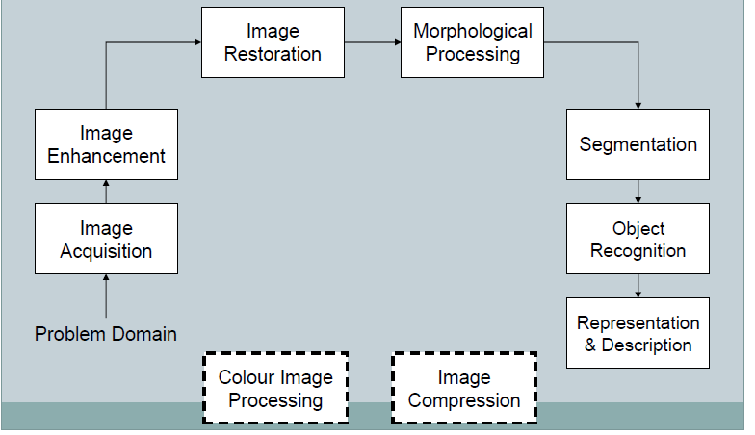

Digital image processing (DIP) is about changing and improving images using computers. Here’s a simple breakdown of the main steps involved in this process.

* **Image Acquisition**: Taking a picture using a camera or sensor.

How it works: You can get images directly from a digital camera. If the image is not digital, you can convert it using special tools.

* **Image Enhancement:** To make an image look better for a specific use.

How it helps: It can make important details stand out.It reveals hidden features that are important for understanding the image.

* **Image Restoration**: Improving the quality of a damaged or poor-quality image.

Difference from Enhancement: Uses math to fix problems in the image. Focuses on making the image clearer rather than just looking nicer.

* **Morphological Processing:** To find and describe shapes in an image.

Use: Helpful in recognizing things like fingerprints.

* **Image Segmentation**: Dividing an image into parts or objects.

Why it matters: Good segmentation is key for recognizing objects in the image.

* **Object Recognition**: Identifying what an object is based on its features.

How it works: Looks at the details of the object to figure out what it is.

* **Representation and Description:** To change raw image data into a format that computers can understand.Types:
* **Boundary Representation:** Focuses on the edges and corners of shapes.
* **Regional Representation:** Looks at textures and shapes.
* **Description (Feature Selection):** Picking out important details from the image.

How it helps: Helps in identifying key features that matter for the task.

* **Image Compression:** To make images smaller in size for storage or sharing.

Use:Saves space and makes it easier to send images over the internet.

* **Color Image Processing:** More people are using color images online.

How it works: Uses color information to find important features.

Applications:Useful in areas like medicine, technology, and more.

Digital image processing includes many steps, each with its own purpose to change and analyze images. Knowing these steps is important for using DIP techniques effectively. Future lessons will focus mainly on black-and-white images.

**Chapter-2**

1. **What are the components of a general-purpose image processing system? Briefly discuss with an appropriate diagram? (JnU)**

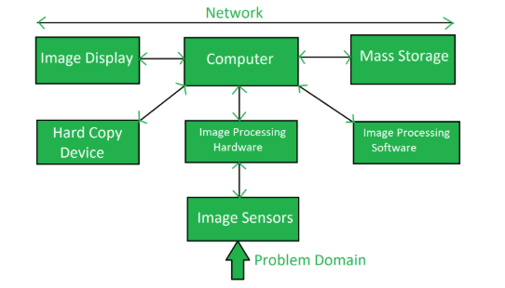

* **Image Sensors:** Capture real-world image data and convert it into digital signals (e.g., cameras or scanners).
* **Image Processing Hardware:** Specialized equipment for processing images (e.g., GPUs or image processors).
* **Computer:** A general-purpose computer running image processing software to process images.
* **Image Processing Software:** Software that applies algorithms for tasks like enhancing or analyzing images (e.g., Photoshop, OpenCV).
* **Mass Storage:** Stores image data during processing (e.g., hard drives or cloud storage).
* **Hard Copy Device:** Outputs processed images to physical form (e.g., printers or external drives).
* **Image Display:** Displays processed images for visualization (e.g., monitors or projectors).
* **Network:** Connects all system components, allowing data to flow between them (e.g., LAN or Wi-Fi).

1. **Sketch a basic structure of Human Eye specifying the important parts. Discuss briefly about Cons and Rods?(JnU)**

**Basic Structure of the Human Eye:**The human eye is a nearly spherical organ with an average diameter of about **20 mm**. It consists of three main layers (membranes) that enclose the eye:

* **Cornea**: The **cornea** is a tough, transparent tissue that covers the front part of the eye. It helps focus light as it enters the eye.
* **Sclera**: The **sclera** is the white, opaque part of the eye that surrounds and protects the internal structures. It forms the outer layer of the eye.
* **Choroid**: Located beneath the sclera, the **choroid** is a darkly pigmented layer filled with blood vessels. It nourishes the eye and helps absorb excess light. The choroid is divided into two parts: the **ciliary body** (which controls the lens shape) and the **iris** (which controls the pupil size).
* **Lens**: The **lens** is a transparent, flexible structure that focuses light onto the retina. It is suspended by fibrous connections to the **ciliary body**. The lens is composed of layers of fibrous cells that are rich in water and proteins.
* **Retina**: The **retina** is the innermost layer of the eye and is responsible for capturing light and sending visual signals to the brain. It contains two main types of light receptors: **cones** and **rods**.

**Cones and Rods:**

* **Cones**:
* **Number**: There are about 6 to 7 million cones in each eye.
* **Location**: Cones are concentrated in the central part of the retina, known as the **fovea**.
* **Function**: Cones are responsible for **color vision** and provide **sharp, detailed vision** in bright light conditions.
* **Rods**:
* **Number**: There are about 75 to 150 million rods in each eye.
* **Location**: Rods are spread throughout the retina, except for the fovea.
* **Function**: Rods are sensitive to **low light** and help with **night vision** and **peripheral vision**, but they do not detect color.

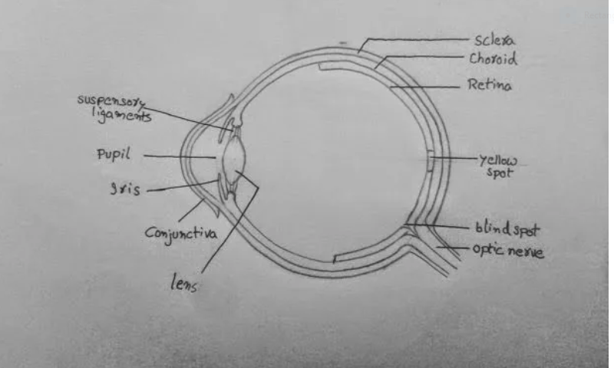

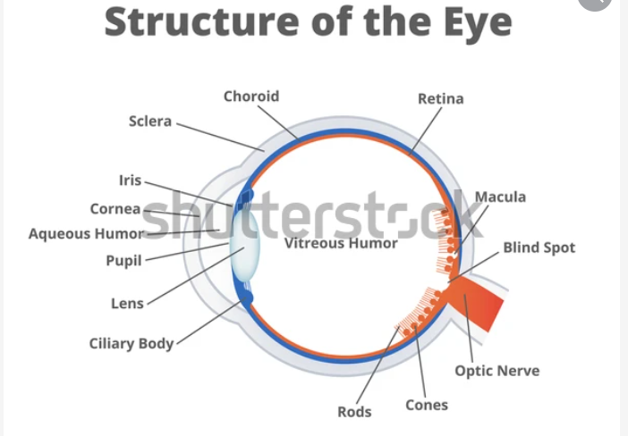

1. **The lens of the Human eye is made up of electronic layers of what?**

The lens of the human eye is made up of transparent, flexible layers of protein. These proteins are arranged in a way that helps focus light onto the retina.

1. **What are the types of light receptors?**

The two types of light receptors are

* Cones and
* Rods

1. **How cones and rods are distributed in retina?**

In each eye, cones are in the range 6-7 million and rods are in the range 75-150 million.

1. **Explain Brightness adaptation and Discrimination?**

**Brightness adaptation** refers to the human eye’s ability to adjust to different levels of light intensity. The eye can function over a very wide range of lighting conditions—up to a range of about 10^10 in photopic (daylight) vision. This adjustment in sensitivity allows us to see in both very bright and very dim environments. The process of adjusting to various lighting conditions is called brightness adaptation.

**Brightness discrimination,** on the other hand, is the eye’s ability to detect differences in brightness levels. At any given level of adaptation, the eye can distinguish only a limited number of intensity levels. If an image uses too few intensity levels (fewer than about 24 in grayscale images), the eye begins to see distinct steps or bands instead of smooth changes. This effect is known as **contouring**.

Another related concept is **simultaneous contrast**, where the brightness of a region appears different depending on the brightness of the surrounding areas. For example, a grey patch may look darker when placed on a bright background, even if its actual intensity remains the same. This shows that perceived brightness depends not only on the actual intensity but also on the context in which it is seen.

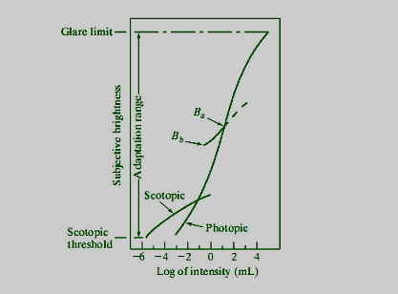

1. **What are the applications of Gamma and X-ray imaging?**

### ****Uses of X-ray Imaging:****

* **Medical Checkups:**Doctors use X-rays to see inside the body, like checking broken bones or lung problems.
* **Dental Care:**Dentists use X-rays to find cavities and check teeth and jaw.
* **Airport Security:**X-ray machines are used to scan bags to find hidden items.
* **Factory Inspection:**X-rays help find cracks or problems in machines and metal parts.
* **Art and History:**Used to look inside old paintings or artifacts without breaking them.
* **Industrial Inspection:** X-rays help detect cracks or faults in metal parts, especially in manufacturing and construction.

### ****Uses of Gamma Ray Imaging:****

* **Medical Tests (like PET scans):**Gamma rays help doctors see how organs are working and find diseases like cancer.
* **Cancer Treatment:**Gamma rays can be used to kill cancer cells.
* **Space Study:**Scientists use gamma rays to study stars and black holes.
* **Checking Pipelines and Machines:**Gamma rays help find hidden damage inside pipes and big machines.
* **Security:**Helps detect dangerous radioactive materials.
* **Industrial Testing:** Used to inspect the quality of welding and detect structural weaknesses in pipelines and machinery.

1. **What is the wavelength range for the electromegnetic visible spectum?**

The **wavelength range of the electromagnetic visible spectrum** is approximately:

**380 nanometers (nm) to 700 nanometers (nm)**

1. **What are the two basic ways of expressing the electromagnetic spectum?**

The **two basic ways of expressing the electromagnetic spectrum** are:

* **By Wavelength**
* It measures the distance between two peaks of a wave.
* Usually expressed in **nanometers (nm)** or **meters (m)**.
* Example: Visible light has wavelengths from **380 nm to 700 nm**.

### ****By Frequency****

* It measures how many waves pass a point in one second.
* Expressed in **hertz (Hz)**.
* Higher frequency means shorter wavelength, and vice versa.

1. **How is color sensed by the reflected light?**

Color is sensed by the reflected light based on how different objects absorb and reflect various wavelengths of light of light.

When white light (which contains all colors/wavelengths) falls on an object, the object absorbs some wavelengths and reflects others. The color we perceive is the color of the **reflected light**.

For example, if white light is shone on a **green object**, the object absorbs most of the wavelengths of light but **reflects green light**. Our eyes detect this reflected green light, and that’s why the object appears green to us.

So, the color we see depends on the wavelengths of light that are reflected by the object into our eyes.

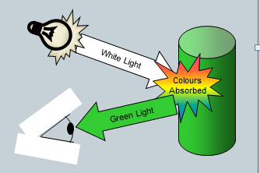 **Extra to know:**

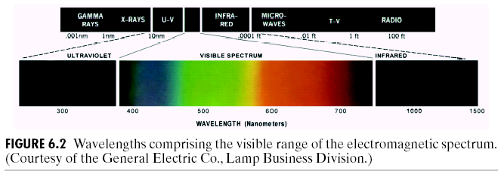

1. **"Perceived brightness is not a simple function of intensity." Justify this statement with two popular visual visual phenomena.**

The statement **"Perceived brightness is not a simple function of intensity"** means that how bright we think something is does not always match the actual amount of light (intensity) it gives off. Our brain plays a role in interpreting brightness, and this can be influenced by context, surroundings, and contrast.

Here are two popular visual phenomena that justify this:

**1. Simultaneous Contrast**

In this phenomenon, a gray object placed on a dark background appears **brighter**, while the same gray object placed on a light background appears **darker** — even though both gray objects have the **same intensity**.

✅ **Justification**: The perceived brightness is affected by the contrast with the background, not just the actual light intensity.

**2. Mach Bands**

When we look at a gradient or a series of adjacent shades (like gradually changing from dark to light), we often see **bright or dark bands** at the borders between the shades. These bands are illusions — they do not exist in the actual intensity levels.

✅J J**ustification**: Our visual system enhances the contrast at edges (due to lateral inhibition in the retina), causing a false perception of brightness changes.

1. **What is the total amount of energy that flows from light source?**

The total amount of energy that flows from a light source is known as its radiant energy or radiant flux (also called radiant power).

1. **Define sampling and quantization. Draw and explain the sampling and quantization process?**

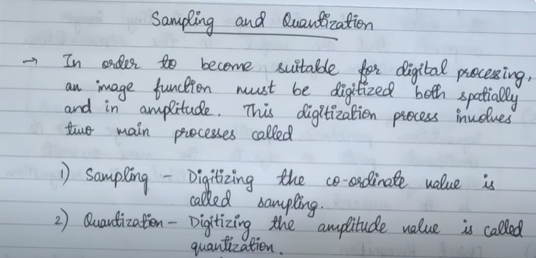

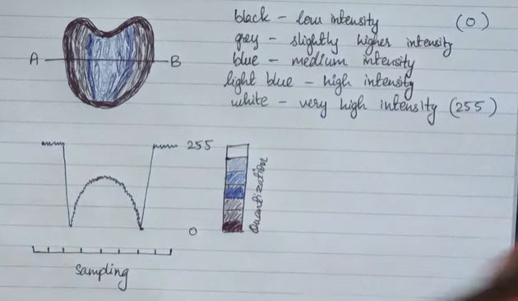

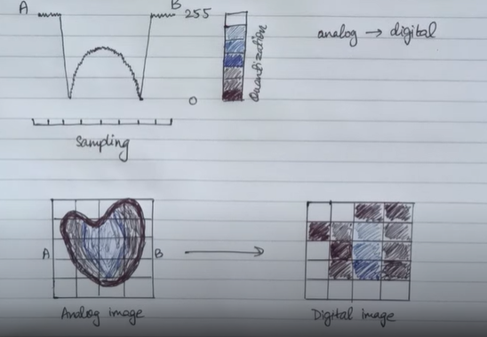

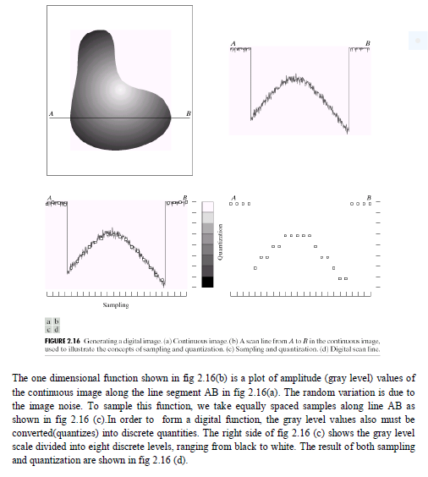

1. **Discuss the image acquisition using a single sensor,sensor strips and sensor arrays?**
2. **Image Acquisition Using a Single Sensor :**

A single sensor, like a photodiode, produces voltage based on the light it receives. A color filter (like green) can be placed in front to detect specific colors better. To create a 2D image, the sensor must move in both x and y directions. This is often done using a rotating drum and a screw-based movement, which gives high-quality images but works slowly.

**Mechanism:**

* The sensor is placed in front of the object or scene.
* A mechanical scanning system moves the sensor across the image (like line by line or point by point).
* Each position gives one pixel value, and the complete image is constructed sequentially.

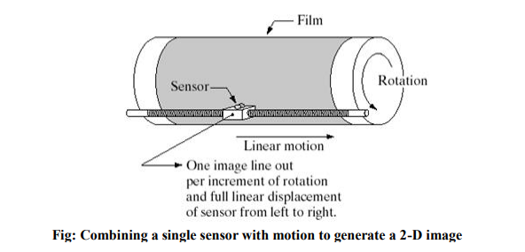

1. **Image Acquisition Using Sensor Strips:**

A sensor strip captures image data in one direction, and movement in the perpendicular direction creates the full 2D image. This method is used in flatbed scanners and airborne imaging, where the strip captures one line as the aircraft moves. In medical imaging like CT (CAT) scans, sensor strips are arranged in a ring, and a rotating X-ray source helps capture cross-sectional images of the body or object.

**Mechanism:**

* The sensor strip moves across the image in one direction (or the image moves past the sensor).
* Each sensor in the strip captures data from one line of the image.
* As the strip moves, each new line is captured and combined to form the full image.

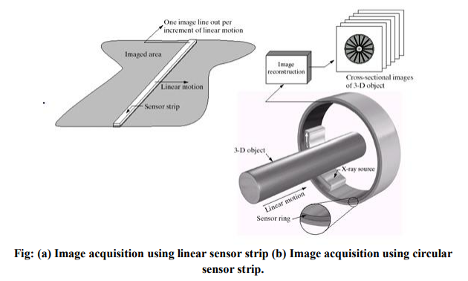

1. **Image Acquisition Using Sensor Arrays**

In digital cameras, a CCD sensor array captures the image. These arrays can have millions of elements (like 4000×4000) and are very sensitive to light. A lens focuses the light from the scene onto the sensor array. Each sensor in the array collects light and produces an output based on the total light it receives. This setup is widely used in cameras and astronomy for clear, low-noise images.

**Mechanism:**

* Each sensor in the array captures the intensity from a specific part of the image simultaneously.
* The full image is captured at once without any physical movement.

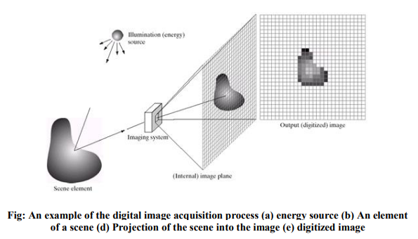

1. **Briefly explain how a digital image is represented in memory?**

An image may be defined as a two-dimensional function, f(x, y), where x and y are spatial (plane) coordinates, and the amplitude of “f ‟ at any pair of coordinates (x, y) is called the intensity or gray level of the image at that point.

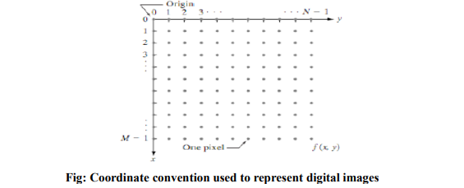

Digital image is composed of a finite number of elements referred to as picture elements, image elements, pels, and pixels. Pixel is the term most widely used to denote the elements of a digital image.

We can represent M*N digital image as compact matrix as shown in fig below



When x, y, and the amplitude values of f are all finite, discrete quantities, we call the image a digital image. The field of digital image processing refers to processing digital images by means of a digital computer.

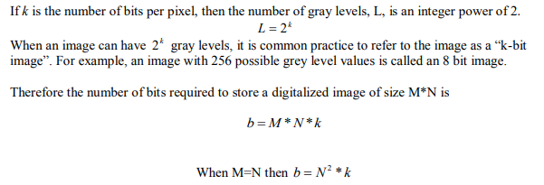

1. **Define photon. Find the number of bits required to store a 256x256 image with 32 gray levels.**

A photon is the smallest unit (quantum) of light or any other form of electromagnetic radiation. It is a massless particle that carries energy and moves at the speed of light.

**2nd part:**

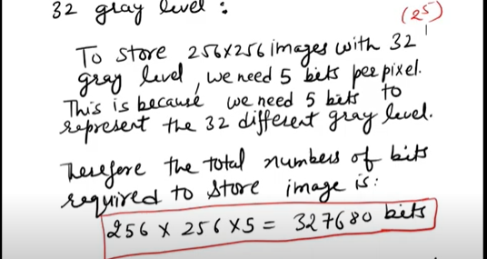

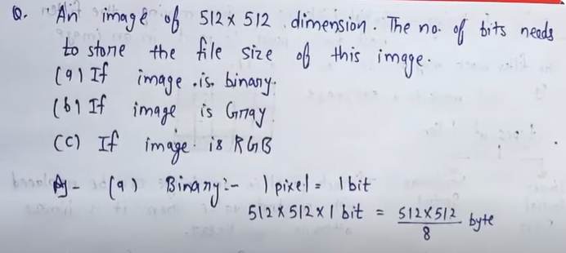

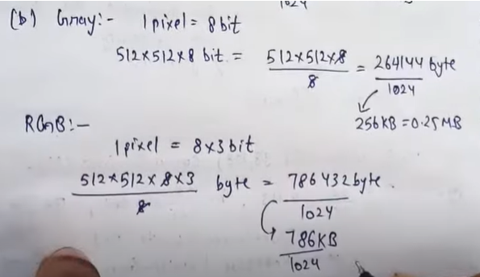

1. **Explain about Spatial and Intensity resolutions. What are the units to measure them?**

### ****Spatial Resolution****:

* **Definition**: It refers to the **smallest visible detail** in an image.
* **Determined by**: How **sampling** is done — i.e., how many pixels are used to represent the image.
* **Higher spatial resolution** means **more pixels** and **finer detail**.
* **Units**:
  + **Pixel size** (used by vision specialists)
  + **DPI (Dots Per Inch)** (used by graphic designers)

### ****Intensity Resolution****:

* **Definition**: It refers to the number of **intensity (brightness) levels** used to represent each pixel.
* **More intensity levels** mean **smoother shading** and **better image quality**.
* **Measured in bits**:
  + For example, **8 bits = 256 levels**, **4 bits = 16 levels**.
* **Higher intensity resolution** = **more detail in brightness differences**.

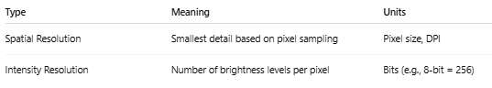

**Basic relationships between pixels**

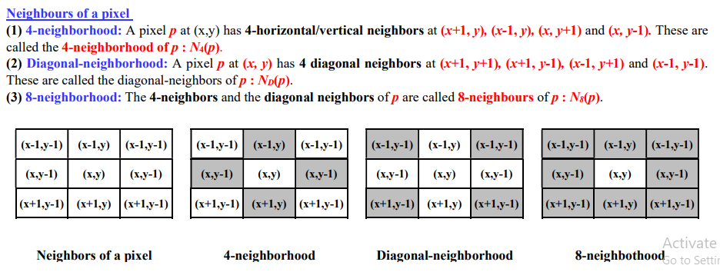

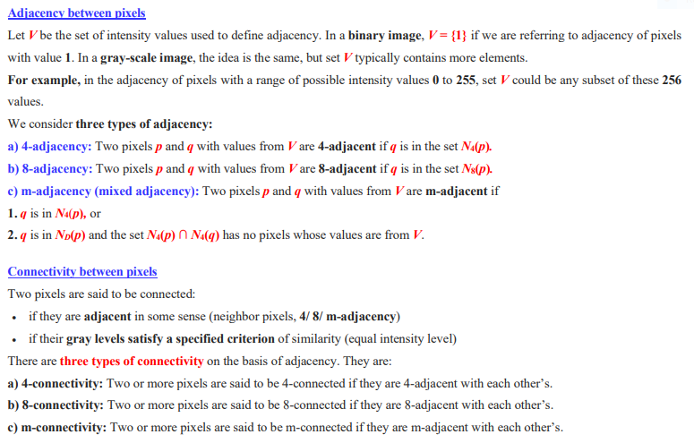

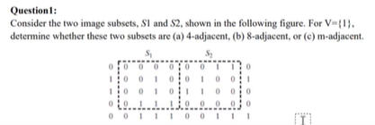

**Solve:**

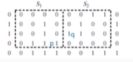

* + - 1. **4-adjacent: q should be in the set of N4(P)**

**No, because N4(P) element is:**

|  |  |  |
| --- | --- | --- |
|  | **0** | **q** |
| **1** | **1 p** | **0** |
|  | **1** |  |

**where 1 of value q is not present.**

* + - 1. **8-adjacent: q should be in the set of N8(P)**

**Yes, because N8(P) element is:**

|  |  |  |
| --- | --- | --- |
| **1** | **0** | **1(q)** |
| **1** | **1(P)** | **0** |
| **1** | **1** | **0** |

**where 1 of value q is present.**

* + - 1. **m-adjacent:** 

**Yes, because N4(P) intersection N4(q) element is: should not be equal to V**

|  |  |  |
| --- | --- | --- |
|  | **0** | **1 q** |
| **1** | **1 p** | **0** |
|  | **1** |  |

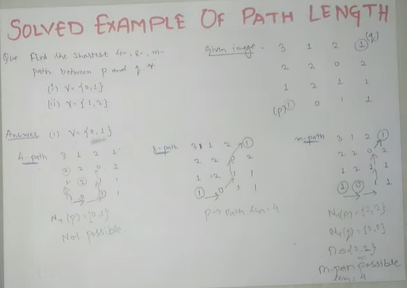

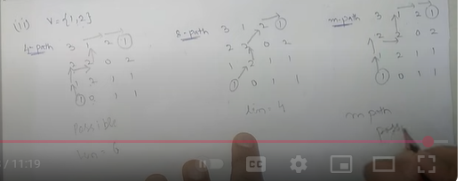

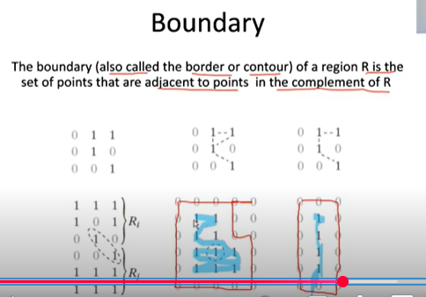

**Chapter:Last**